Comp 3006 Full Stack
Youtube video: https://youtu.be/UnfO1ea_TlY
Github: Plymouth-University/coursework-b-a-hanley: uop-comp3006-2024-coursework-comp3006-assessment-template created by GitHub Classroom
Requirements (ca. 400 words with additional documents in appendices)
The application is aimed for purchasing of food at tofu restaurant, this is so that anyone can order, and staff can change the system as required.
Would, Should, Could
As a staff member I want to
- Add Menu Items incomplete
- Update the menu items incomplete
- Delete the menu items incomplete
- Get a specific menu item incomplete
- Get all menu items
- Get all orders
- Edit an order incomplete
- Create an order incomplete
- Delete an order incomplete
- Help support guests incomplete
- Want my functionality to be behind a password incomplete
- Menu items to have photos incomplete
As a guest I want to
- Get all available menu items
- Get a specific menu item incomplete
- Create an order incomplete
- Edit an order incomplete
- Delete an Order incomplete
- Get support if I have issues incomplete
- Remove ingredients from item incomplete
- Get my previous orders incomplete
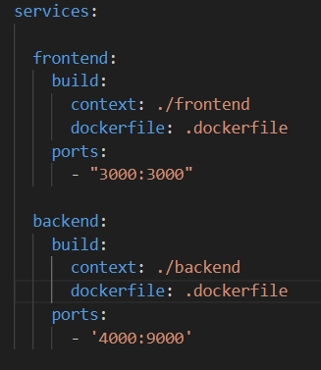
Design (ca. 500 words with UML diagrams)
What is the system architecture (clients/servers/peers)?
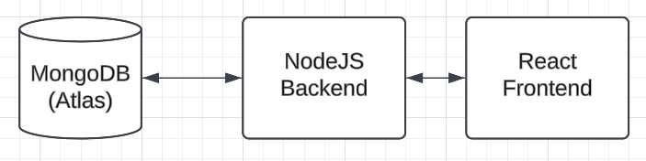
Structure

Class diagram
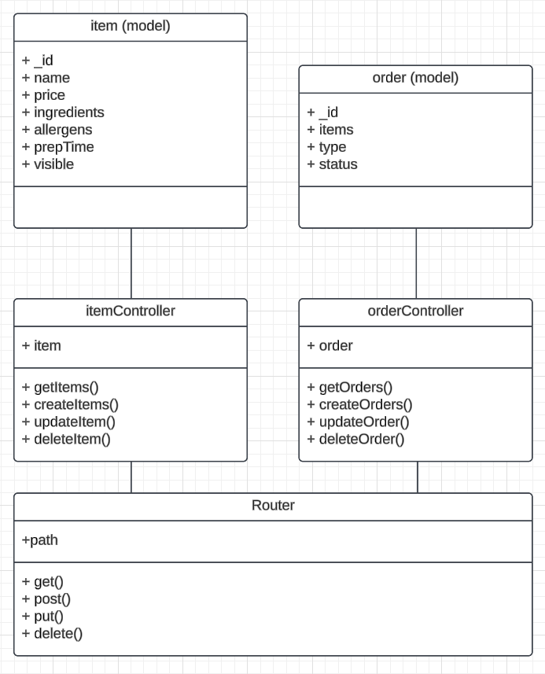
Original wireframe although outdated
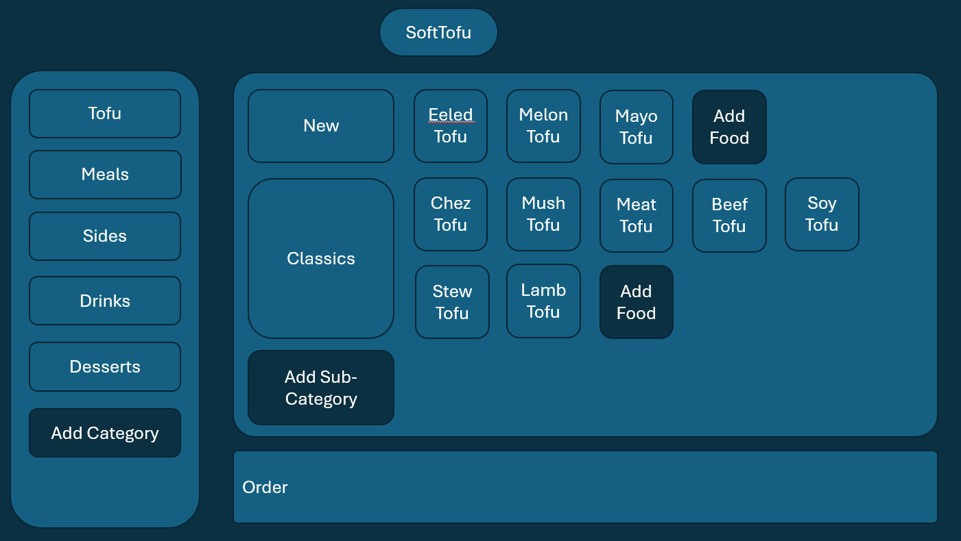
Testing (ca. 400 words)
What manual testing did you perform?
When the database wasn’t linked to frontend, I performed mocking to ensure that that when frontend received data that it could present it in the right form.
const orders = [
{
id: 'Tofu',
items: ["Tofu"],
type: "takeaway",
time: "now"
},
{
id: 'Eeled Tofu',
items: ["Eel", "Tofu"],
type: "sit-in",
time: "now"
},
{
id: 'Mushroom Tofu',
items: ["Mushroom", "Tofu"],
type: "takeaway",
time: "now"
}
]

export default function OrderList(order) {

return (

<div style={{marginLeft: "50px"}}>
<h5>Orders</h5>
<div class="row">

{orders.map(order => (
<div class="card col-sm-3" key={order._id}>
<div style={{display: 'flex', justifyContent: 'space-evenly'}}>
<div>
<p>{order._id}</p>
<p>{order.type}</p>
<p>Orders: </p>
</div>
<div>
<p>0:00</p>
</div>
</div>
</div>
))}

</div>
</div>
)
}
DevOps pipeline (ca. 400 words)
Describe your development environment.
My development environment is visual studio code being a free, light weight and highly versatile environment to program in. I have the added strength of familiarity with it from previous projects. The use of extensions in visual studio code can be beneficial code formatters which improve speed. Version control was done through GitHub a popular open-source version control system. I attempted to work on a ci/cd pipeline but I couldn’t figure out how it worked in the end. I worked on a develop branch and pushed good code to the main branch.
Personal reflection (ca. 300 words)
What worked/didn’t work well (techniques and technologies you used)?
I didn’t work effectively during the start of the semester and depended upon the Christmas break to catch up with work. I experienced an issue for three weeks which was eventually resolved once I realised the error that was being caught was in json.package that was deleted. The file itself was still called despite being deleted as it was at the route of the directory unlike the other json.package files. I was unable to locate the error as it was deleted. The use of version control really benefited me upon realising the issue I went back to a previous version of the system and could edit the file to remove the error before deleting it once more. Unfortunately, things took a turn for the worst as I developed a bad chest infection. Working consistently allows for the delays of everyday life to not be a barrier to produce good work. Given the delays I experienced I still believe there has been some good work. The two docker containers run and backend links to atlas. I am able to complete all crud operations via the backend API. I was able to install a primitive Gui through CSS and bootstrap. Unfortunately only getOrders and getItems are the only frontend connection. I was able to get some form data read which could be in future linked to createItem and updateItem. I think the lesson I have learnt is work consistently but also learn how to focus on other features rather than focussing on just one. After realising the time pressure, I found it hard to maintain the right work balance whilst suffering with an illness as I felt the work must be completed.

